Ui-path support for containerzing using automation using DOCKER container.

* UiPath Studio or UiPath Studio-X as you normally would.
* Package your automation process into a NuGet package. This can be done using the UiPath Publish functionality, which generates a NuGet package containing your workflow and its dependencies.
* Create a Docker file that describes the container image. The Docker file typically starts with a base image that contains the required runtime environment, such as the UiPath Automation Base Image. Then, we copy our NuGet package into the container and specify the entry point for the bot.
* Docker Image is build , we can run the container using the **docker run** command. we may need to provide additional environment variables or mount volumes depending on the requirements of our bot.

**Note :**

**NutGet Package :** a NuGet package is a single ZIP file with the . nupkg extension that contains compiled code (DLLs), other files related to that code, and a descriptive manifest that includes information like the package's version number.

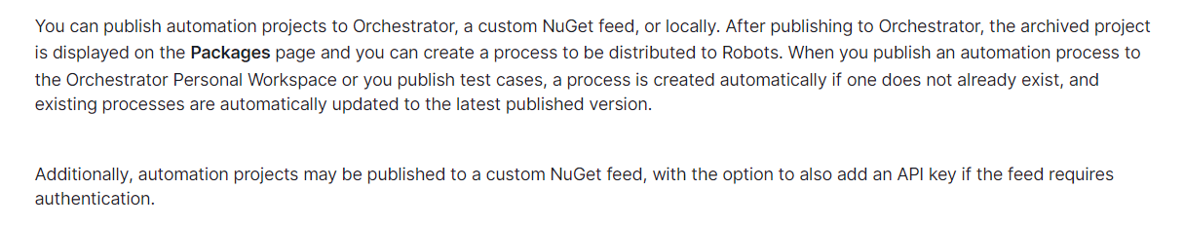

Link: <https://docs.uipath.com/studio/standalone/2023.4/user-guide/about-publishing-automation-projects>